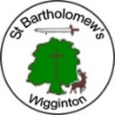 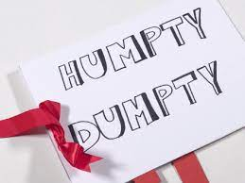

|  |  |  |  |
| --- | --- | --- | --- |
| **St Bartholomew’s Knowledge Organiser**  **Design Technology** | **Class 2** | **Autumn 2 DT–**  **Year 2021-2022** | ***Mechanisms – Making a Moving Storybook*** |
| **What we will learn:** | | **Success Criteria:** | |
| In this unit you will learn to;   * explore making mechanisms * understand that sliders are mechanisms * know that sliders can make things move * create moving models that use sliders * use the words: up, down, left, right, vertical and horizontal to describe movement * design a moving story book * design three pages of my moving storybook by:   + drawing background pictures   + drawing the moving parts   + deciding whether I will use a side-to-side slider or an up-and-down slider on each page * labelling the movement of each type of slider * construct a moving picture * make my moving picture by:   + Drawing my background   + Drawing and cutting my moving parts   + Making sliders for my moving parts   + Putting all my parts together to create my moving picture * possibly making guides and bridges * test finished storybooks with target audience * evaluate their end result against initial design criteriacriteria | | * I understand that sliders are mechanisms * I know that sliders can make things move * I can create moving models that use sliders * I can use the words: up, down, left, right, vertical and horizontal to describe movement | |
| **Important Vocabulary** | |
| **Assemble – to fix all parts together**  **Design – to make, draw or write plans for something**  **Design criteria – a set of rules to help you with your ideas and test the success of them**  **Evaluation – when you look at the good and bad points about something, then think about how you can improve it**  **Mechanism – a system of parts working together**  **Model – a practice version, often on a smaller scale, that lets you test out your idea and see how it will look and work**  **Sliders – something that you can move from side to side or up and down**  **Stencil – a shape which you can draw around**  **Target audience – a person or particular group of people at whom a product is aimed**  **Template – a stencil which you can use to help you draw a shape more easily on to different materials**  **Test – to find out if something works as it should** | |